Sensitivity plot plays a vital role in understanding combined effect of input variables on an identified output variable. Typically it is difficult to obtain single parameter effect as many parameters change simultaneously. In this exercise one should use the test data provided and come up with plot to see the trend and table with change in input variable.

Data set

File <- actual_data.csv

Column names – TestNumber, Input and Output.

Rows – data corresponding to each test.

**Sample output plot**

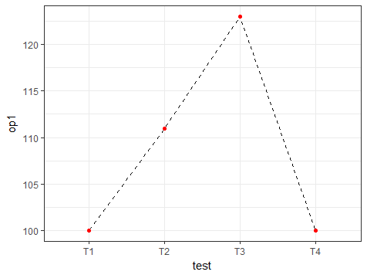

**Sample Table**

|  |  |  |  |
| --- | --- | --- | --- |
|  | T2-T1 | T3-T2 | T4-T3 |
| ip1 | 2 | -2 | 0 |
| ip2 | 0 | 20 | 40 |
| ip3 | 1 | -1 | 1 |
| ip4 | -0.1 | 0.2 | -0.1 |